**HOW TO MAKE A TNT IN MINECRAFT**

In this article, you will come to know **how to make TNT in Minecraft**. Minecraft is a 3-D game sandbox video game and it is a brick-based game. A specialty in this game is **“You can kill spiders, take their webs, and use them as bowstrings in wooden bows**”. Minecraft is treated as the best game due to its features. It is an educational type of game for kids and a non-violent game can teach programming skills.

TNT is a craftable block that explodes 4 seconds after being ignited and it can destroy its surroundings, and the easiest way of obtaining is by crafting. TNT is ideal for excavating several blocks at a time, or as a trap for Mobs and/or Players. Once activated, TNT turns into an entity, which includes being affected by gravity.

**Required Items:**

* 5 Gunpowder
* 4 sand blocks

**How TNT looks:**

**Steps to make TNT:**

**Step 1:**  First we need to search for creepers to get gunpowder. Generally, creepers will drop 0-2 gunpowder after killing them. So, our primary step is, to find and kill as many creepers to get the required gunpowder.

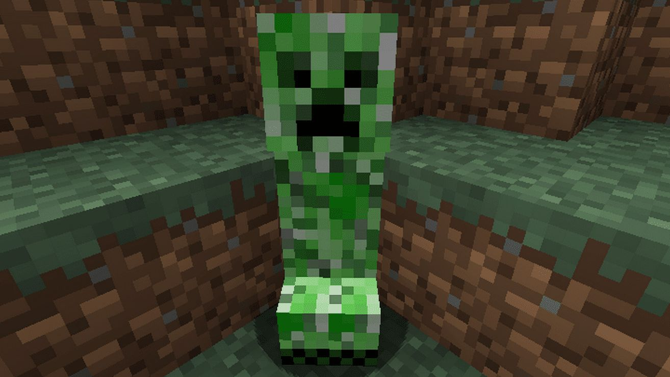

**Step 2:** After collecting the gunpowder we need to search for sand blocks. By using sand blocks, we can construct TNT. We need to collect 4 sand blocks.

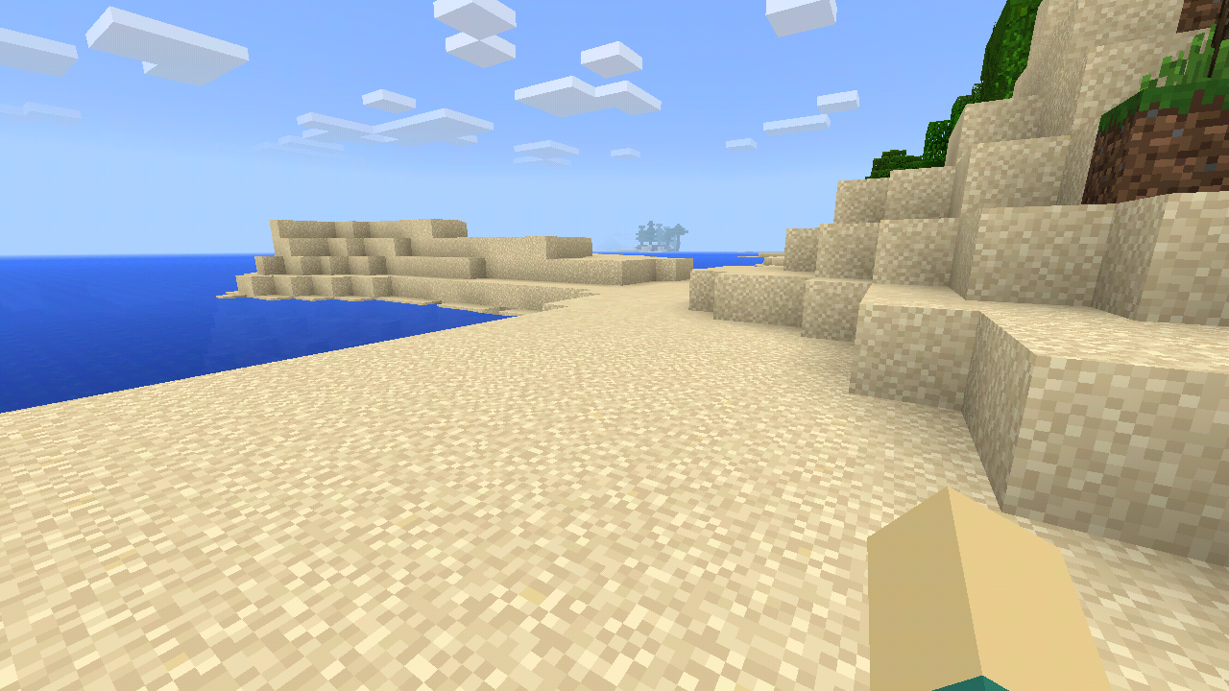

**Step 3:** After collecting both gunpowder and sand blocks, open the crafting table and place the collected items alternatively in a 3 x 3 grid system. Start placing with the gunpowder.

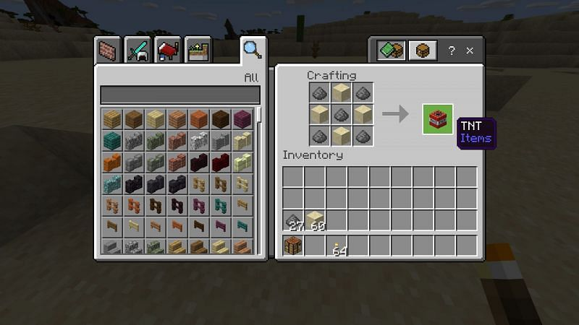

Place the items as shown in the above figure. By placing the gunpowder and sand blocks we are done with making TNT. Now we had another task, it is activating the prepared TNT.

**ACTIVATION OF TNT:**

We need to be careful while activating TNT. Because it is a blasting device. Blast can affect the surroundings. **It does not destroy any blocks when they are surrounded by water or lava but deals damage to anything within the blast radius.**

**TNT will activate when it receives power from a lever, Redstone torch, button, pressure plate, or any other activator. It is also affected by gravity only after being activated and can fall about seventy blocks before it explodes. TNT will take nearly 4 seconds to blast, so we need to move away from the TNT in those four seconds.**

There is a specific kind of joy you can experience seeing an incredible Minecraft world and blowing it to smithereens. The explosion on its own is enough to blow a hole in the wall of your house, but with hundreds, you could potentially crash the world. Be careful when you use TNT, make sure you only use it where you want to use it.

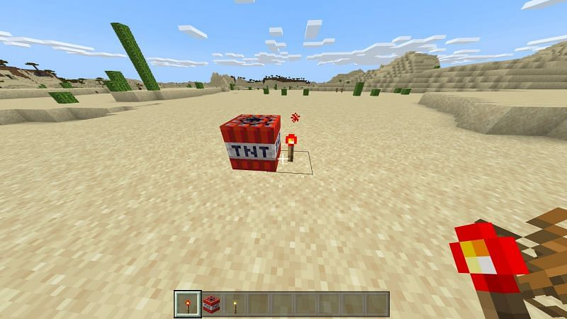

After activating the TNT, you will be able to see that there is a small flash. It is the starting of the blast and it will take near of about 4 seconds.

**AFTER BLAST:**

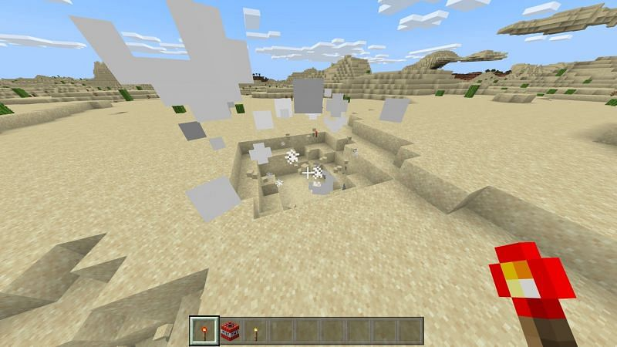

The blast may take in different ways,

* Blasts only a single TNT. It can happen only by lighting that TNT.
* Can blast by the effect of nearby TNT blasts.

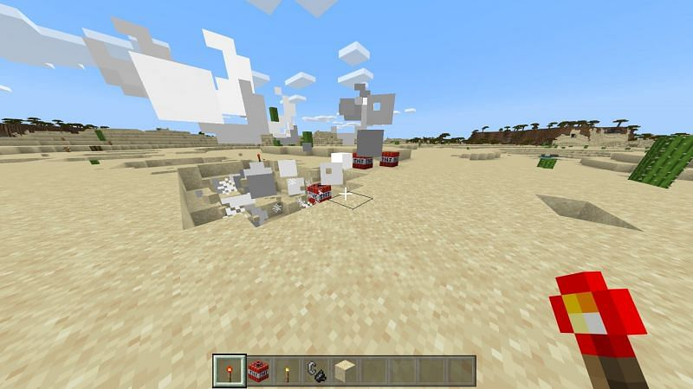

Here we can see that there are many TNT’s nearby.

**The behavior of TNT:**

TNT behaves much like one would expect it to. It will light when activated by Redstone currents or with fire, and the explosion will cause nearby TNT to also explode. TNT is also affected by gravity, but not when it is placed. You can place TNT above a large drop, and it will not fall until you light it. It will fall about seventy blocks before it explodes.

**How much damage does TNT do?**

Being in the middle of the blast radius will do about twenty-five points of damage or twelve and a half-full heart. The damage you take depends on the proximity to the TNT explosion, but the maximum per explosion is about twenty-five points of damage. ­­­­

**Special Features of TNT:**

You can use TNT to break into the top of underwater temples. There is almost always an elder guardian in the top middle room of an underwater temple. Breaking in with mining fatigue can take a long time. Just light some TNT into the water and place sand above it so that the TNT is technically in a sand block instead of a water block. The explosion will break blocks as normal.

**Uses of TNT:**

* **The classic use for TNT in Minecraft is to prank and trap players.**

It's straightforward to use TNT in a prank. All a player has to do is get a little bit of Redstone, a pressure plate, a few blocks of TNT, and wait for their victim to fall into their trap.

* **Mob Forms & Fights**

Mob farms are a great way for players to gain XP and loot from mobs. TNT is one of the key components in many mob farms. Mob farms differ in design, and players are creating more farms every day.

* **Canons and TNT flying Machines**

These days, players are capable of crazy Minecraft contraptions. Two notable ones are canons and TNT flying machines.

Canons can be used to launch TNT on other players. To make a cannon, players need a variety of resources and skills. [Click here to learn more](https://www.sportskeeda.com/minecraft/news-how-make-minecraft-tnt-cannon) about the process of making cannons.

TNT flying machines are a little more complicated. These contraptions require pistons and Redstone. They can be difficult to make, especially in vanilla Minecraft.

**CONCLUSION:**

I hope that this article helped you a lot in making TNT in Minecraft. Be careful while activating the TNT, the blast may affect its surroundings and damages. Please don’t keep the TNT behind the Lava or any other TNT blocks. These may blast the TNT’s subsequentially. Please share and play with your friends and have fun. And lastly, if you enjoyed reading this article and find it helpful, do share it with your friends.

**Article by,**

Noone Harshan

9550949044